Creating our Work Breakdown Structure
Normally the first thing that we need to think about are the tasks and their dependencies. So login into your LibrePlan installation and from the main screen click on Projects List.
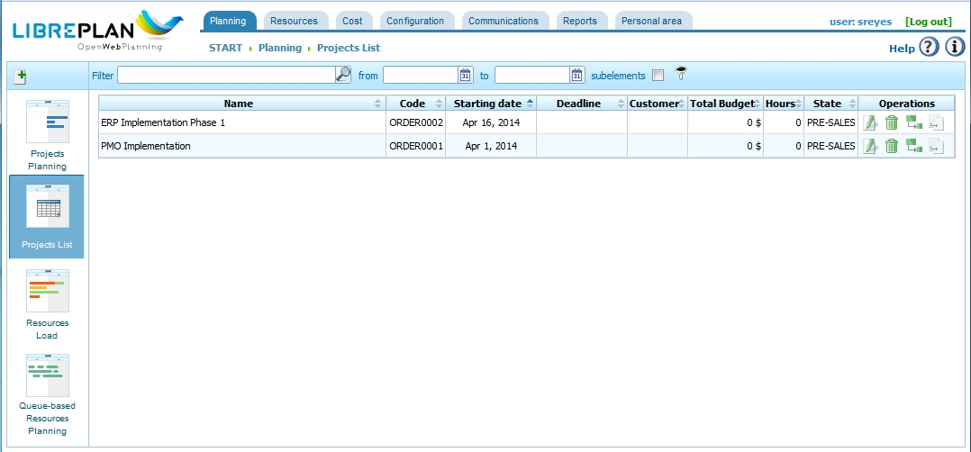
Image 1
Press the add project button and define our project data. You can get LibrePlan auto-generate codes for your projects too, but in this case we’ll define the project code manually.
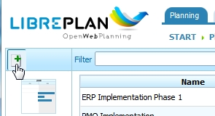
Image 2
When you have entered the Name, Code and Customer, press Accept and you’ll be greeted with the default Work Breakdown Structure screen. If you have defined a custom calendar, make sure you select the correct calendar. Otherwise all the information here is editable from the General Data tab.
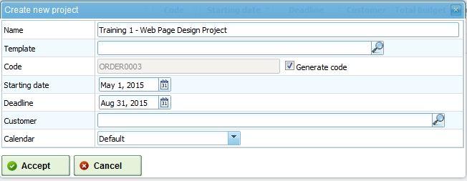
Image 3
So now let’s try adding some tasks that we would likely have to do if we develop an online market website.
Inserting Tasks
Groups in the WBS (Work Breakdown Structure) window is basically started as a normal task. This is similar to what you would have to do in MS Project.
So let’s add the Graphic design group stage and their tasks. In this instance my graphic design work group will consist of:
- the welcome page
- product listing
- single products listing
- checkout process, and
- order confirmation design.
We’ll define those as separate tasks. In order to make sure that they are under the graphic design group all we have to do is indent the task one level below the graphic design group.
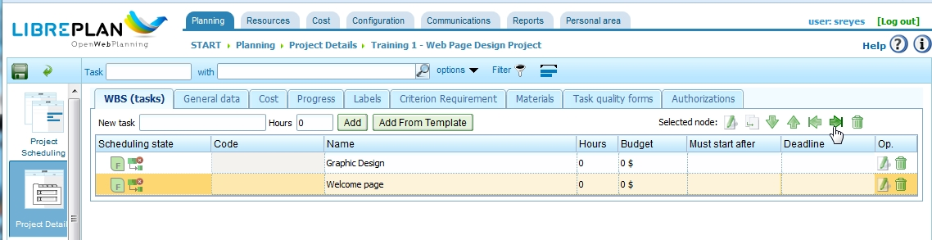
Image 4
I hope that illustrates the way we add tasks into the WBS listing. To move further we should add more groups and tasks so that our example project looks more real.
To sum it up, we should enter these tasks below. Now again, this is an exercise to demonstrate what LibrePlan can do. A real plan would have been much more detailed than these tasks below. Also yes, in this case study, we have decided to use an out-of-the-shelve open source online store application, therefore we can assume not much development is required for the admin and accounts side of things.
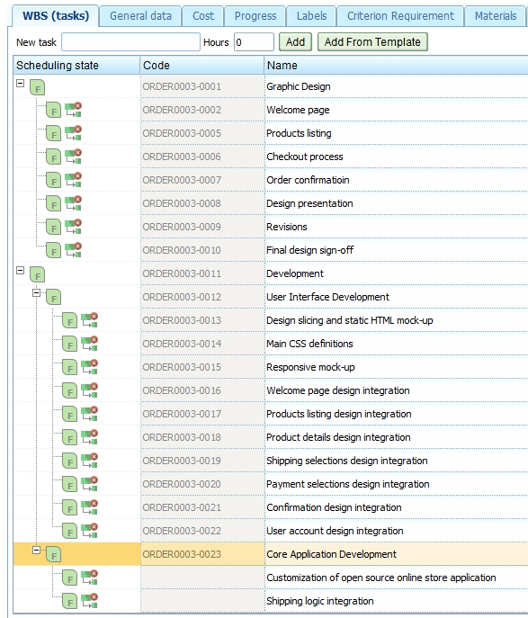
Image 5
Indenting tasks is very important, and given that the web interface doesn’t allow for the use of our keyboard Tab key, you can indent a task after it was entered by “selecting it” (click on the task and the background color will change to light orange) and then pressing the tab icon as represented in the image before the present one (something like =>| ). Alternatively, you can select the “base” entry as in this image (ORDER0003-0023) and as you enter New Task and Add, it will be automatically tabbed, using the selected task as parent.
Scheduling
Once all the tasks are entered as indicated above, you will end up with a list of tasks with the same Start and End dates. It is now time to adjust those dates according to our calculation of the time that it will take to perform each task. This is better accomplished in the Project Scheduling view. To get there, click on the Project Scheduling button on the left panel.
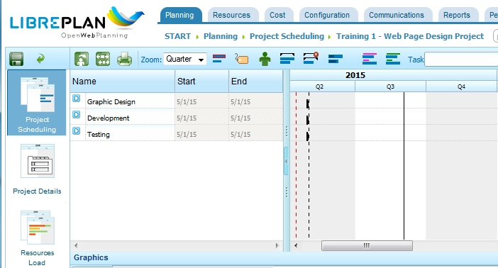
Image 6
Note that you are only seeing here the high level task headers for the 3 stages of this project. 1) Graphic Design, 2) Development and 3) Testing. When you click on the “expand” button next to Graphic Design, for instance, it will display all tasks under that header.
As we started defining our project, we determined that this would go from 5/1/15 through 8/31/15, four months.
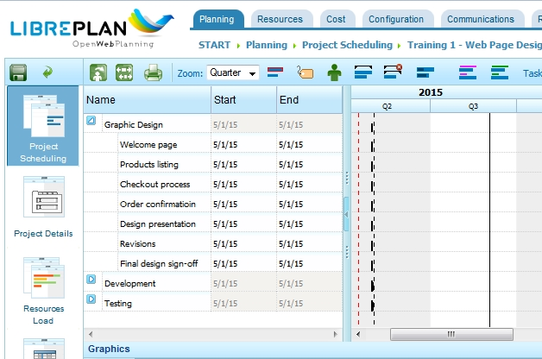
Image 7

The indentation has determined a hierarchy of tasks. You cannot change the dates for “Graphic Design”, these are determined by the tasks that fall under that stage.
Our completed scheduling will be shown on next page.
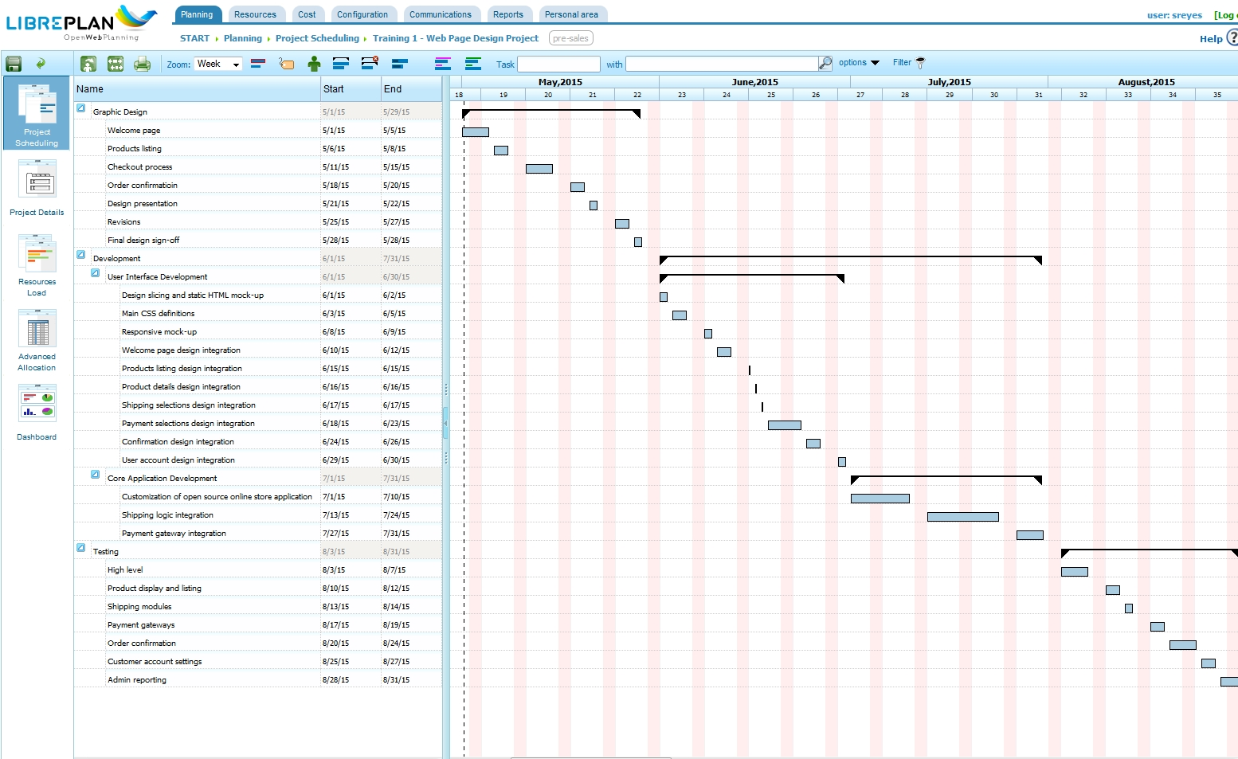
Image 8

Dependencies
Now notice that some of the tasks above will have some dependencies. It’s easiest to link the dependencies from the project scheduling view.
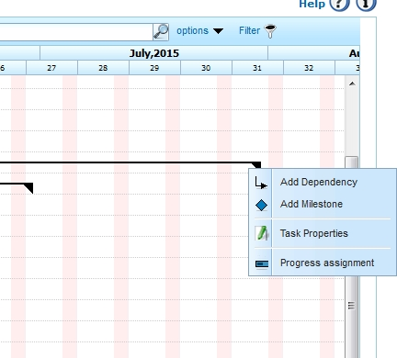
Image 9

To add a dependency, place the mouse pointer on top of the bar you want to add the dependency then right-click on it. A menu with the options to Add Dependency, Add Milestone, Task Properties and Progress assignment will open. When you click on Add Dependency, a graphic line will open that you extend to the bar where the dependency will link. In the graphic below we can see that we created dependencies between stages and also within the two processes within the Development stage. Note that the Gantt “zoom” was set to “month” instead of “week” for a more compact look at it.
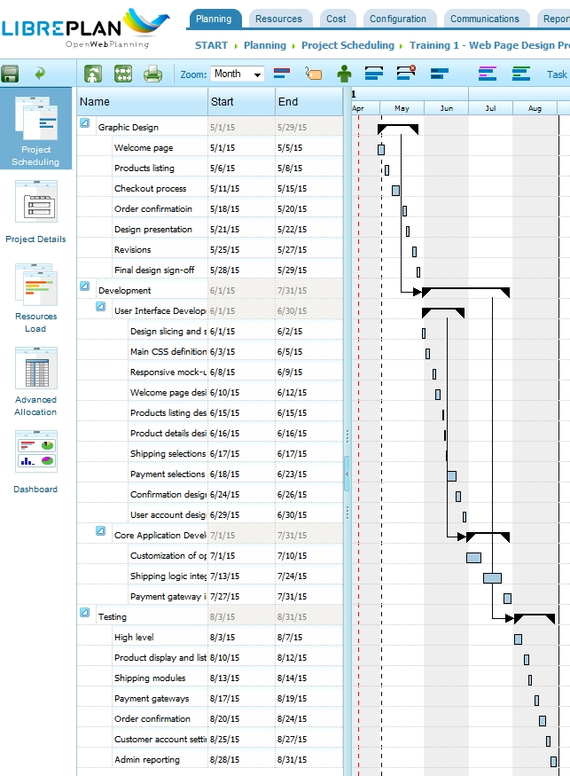
Image 10
Hours and Budget
As you can see from the above picture, things are starting to shape up. Now the only thing that we have to do is insert the hours listing. We accomplish this by using the “Project Details” view. Notice that we assigned hours for all tasks in the Graphic Design stage (40, 24, 40, 24, 16, 24 and 16), which the system added automatically to indicate that the Graphic Design stage will take 184 hours to complete.
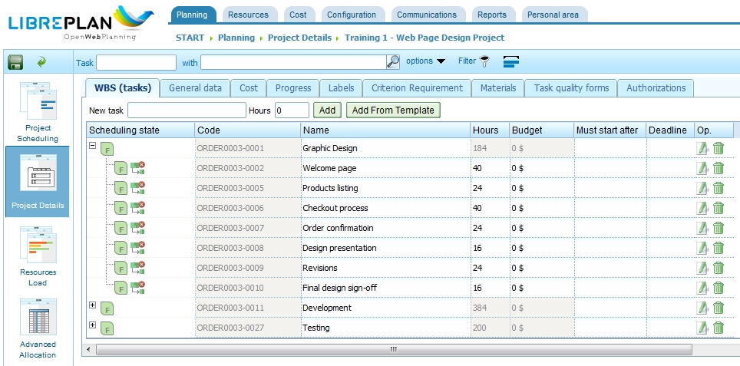
Image 11

Likewise, we could add Budget data on this same screen. That date will also be added to indicate how much funding is allocated to accomplish this stage. The image bellows shows completion of budget data.

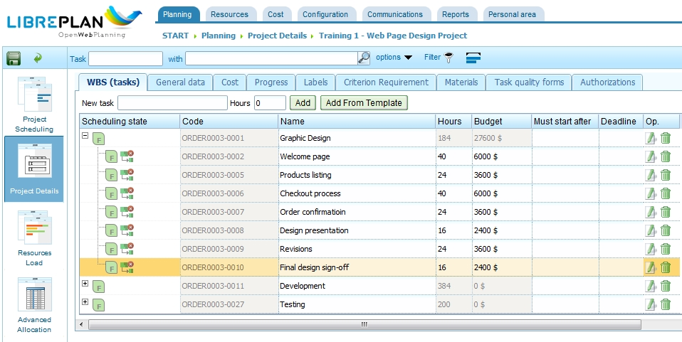
Image 12
Creating Project Workers
Before you can assign team members to tasks, you have to create resources, in this case, workers. To do this, click on the “Resources” tab, and then “Workers” on the resources pull down. Notice the other resources you can work on under this tab (Machines, Virtual Workers, Calendars, etc.). Once in the Workers screen you click on the “Create” button to add team performers.
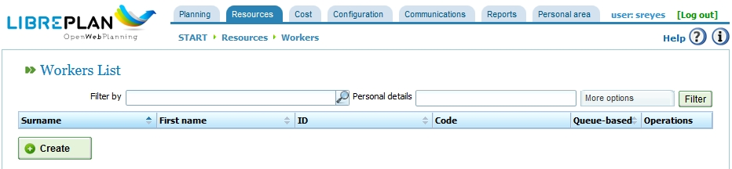
Image 13
On the next screen after clicking on Create you will enter the worker information.
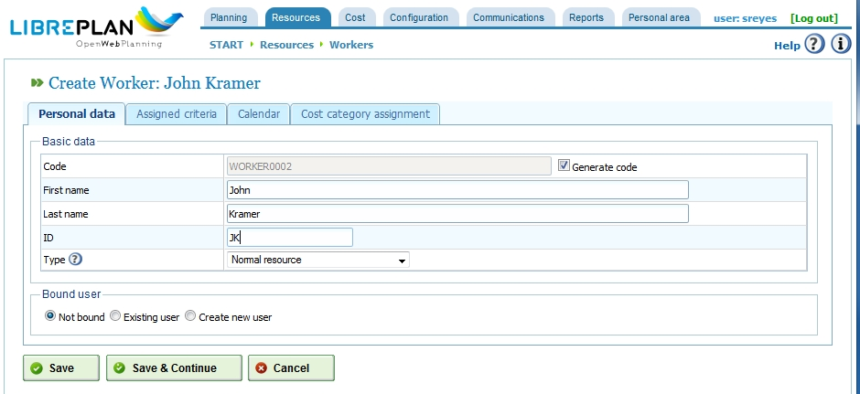
Image 14
To save the information entered, click on Save, then press Create and continue the process. Using Save & Continue might not work as expected. After a while the list of workers could look like this:
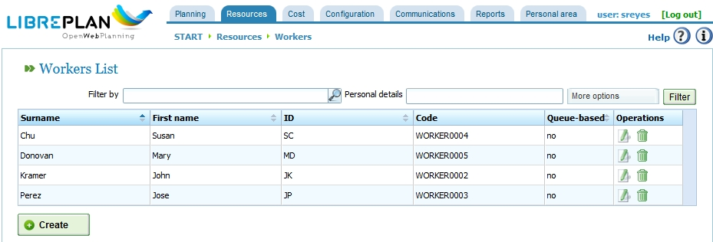
Image 15

Assigning Team Members
Now that we have all the tasks listed and a list of team performers, we will assign our team members to each of the tasks. To do this, move to the Project Scheduling mode and expand all the groups.
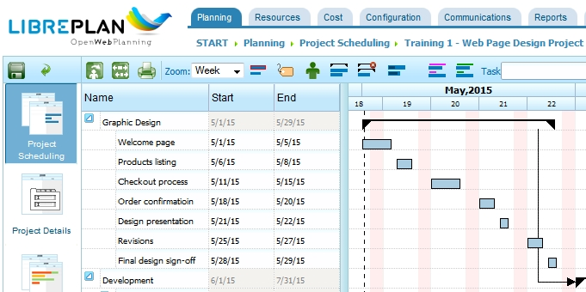
Image 16

In addition, to make things easier I enable the Show Resources mode.
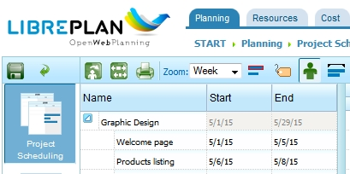
Image 17
You’ll see all of the tasks that we have defined previously as bars on the Gantt chart. As we assign the correct team members the task length will then be calculated automatically.
In order to assign a resource, simply double-click on the bar belonging to the task you want to document. This action will bring up the task option dialog box.
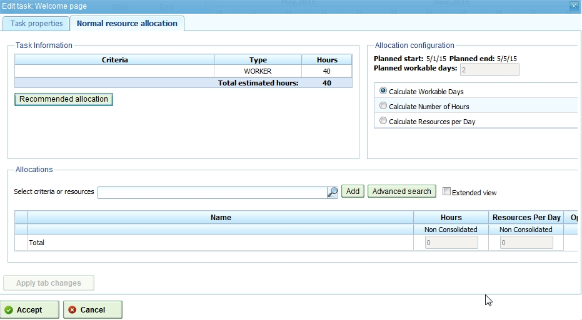
Image 18
Assigning resource to the task is pretty straightforward too, simply type the name of the team member and LibrePlan will autocomplete it. Optionally, you can click on the search icon and select the correct “Worker” (team member) from the pull down list. In this case we selected team member John Kramer and assigned him to this 40-hour task.
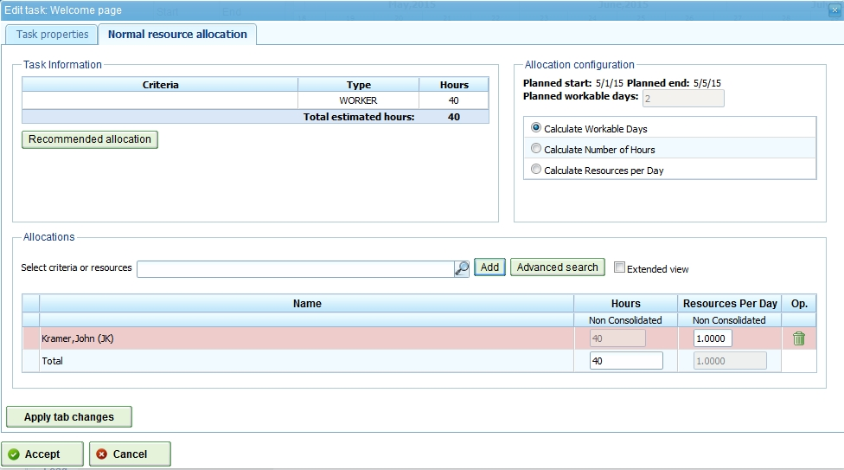
Image 19
Once you press Accept, you’ll see that the task bar now has a darker blue color and with the Show/Hide Resources button selected, it will also show the name of the team member responsible for the task. All we have to do now is follow through and do the same with the rest of the project items.
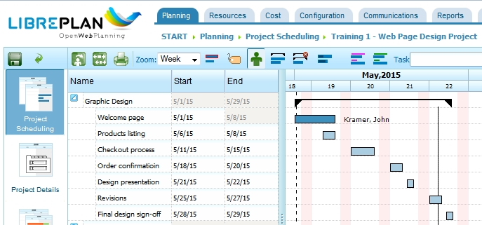
Image 20
Managing Dependencies and Task Resource Load
What we just did in the previous section is assigning designers and developers to the specific tasks with no regards to dependencies or their load. Obviously one person cannot do more than one tasks in parallel unless they are only working at certain percentage each, which makes things complicated. LibrePlan actually tells us about load problems on the bar at the bottom of the Gantt chart.
So in order to avoid having this issue we need to schedule so that one person’s task happens after another.
Firstly, we made sure that the stages are happening one after another. To do this, we created the dependencies by right clicking at the end of the stage boundary and selecting Add Dependency. Then chose the stage that it depended on. This is very useful for proper planning.
Lastly, for simple project like this, we’ve put the task dependencies depending on who’s doing what. This way our resource allocation will be correct and we’ll get the proper estimated dates. Again, this is similar with assigning the group dependencies.
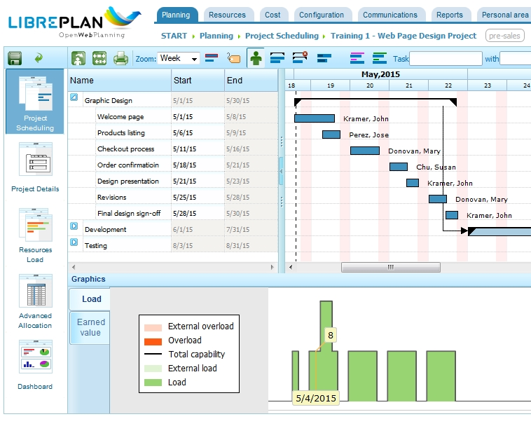
Image 21
We can be sure there is no overload because there are no orange indications in the load graph. We will assign “Products listing” which overlaps with “Welcome page” to John Kramer to observe the resulting overload on the Load graphic:
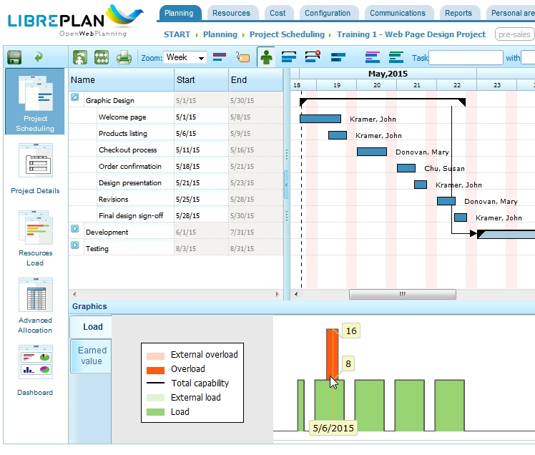
Image 22
Progress Tracking
One of the most important things that we want to track in a project is our progress. In order to do so we will need to assign percentage complete for each of the task as it moves forward. Let’s just say for the sake of this article that the Welcome page task has been done by roughly 30%. To assign this all we have to do is right click on the task bar and click on Progress Assignment. You’ll be greeted with the progress assignment page and you can add a measurement and its value. To do this, click on “Add measure” and add the information in the “Value” data box. You could actually assign different measurements other than percentage if you choose to do so.
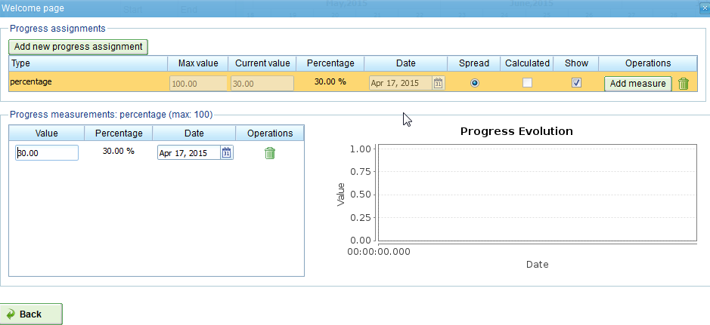
Image 23
The 30% progress will be recorded when you click on the button “Back” (which should have been labeled Save, instead). In order for this progress to be visible on the Gantt Chart the “Show/Hide Progress” button must be selected. This is how it will look:

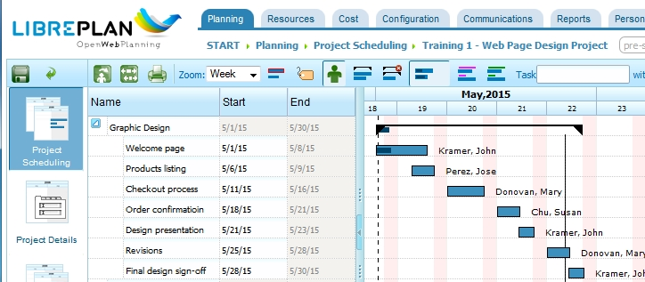
Image 24
Notice that the Welcome page task bar now has a black bar inside the blue bar. Also notices that the black bar under Graphic Design also has a similar dark bar underneath.
To see the overall project performance and metrics such as total hours required, etc; navigate back to the Project Details screen. As mentioned above, we want to see how many percentages this project has progressed after modifying the Progress Assignment. Click on the Progress tab to see the total percentage progress of the project. At this point we can see that we have 1.00% complete out of the whole project.
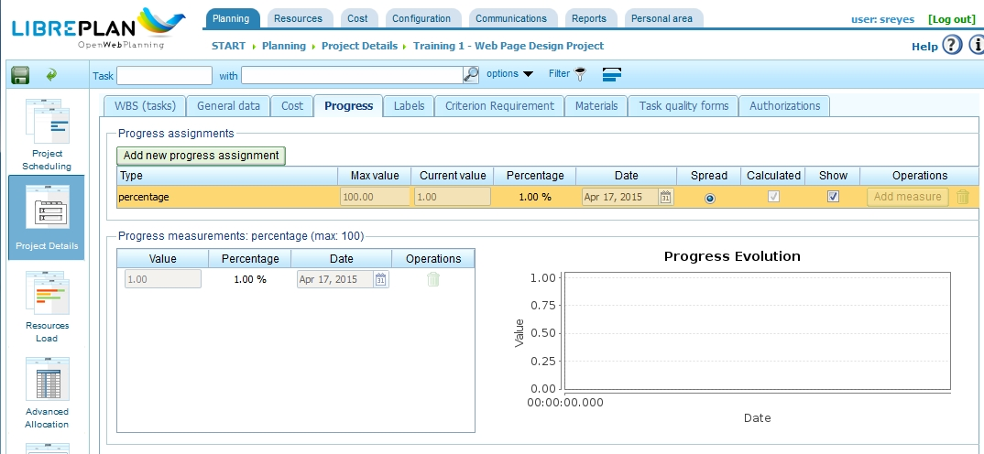
Image 25
In a real project you will definitely see a graph in the progress evolution area. This is one of the helpful indicator of how the project is tracking.
Reporting
LibrePlan supports a limited array of reporting options. You can explore their reporting features from the Reports tab. In order to maximize the usage of the reports, we need to input all the correct project progress information, which of course we do not have in our example.
Presently, the following reports are available: Hours Worked Per Resource, Total Worked Hours By Resource in a Month, Work and Progress Per Project, Work and Progress Per Task, Estimated/Planned Hours Per Task, Project Costs, Task Scheduling Status in Project, Materials Needs at Date, and Project Status.
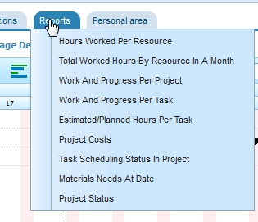
Image 26

Conclusions
To conclude this LibrePlan series I’d like to close up with a couple pros and cons of this tool.
- Pros:
  - Free open source product.
  - Great Gantt chart which is very usable unlike other tools that I have tried. This is actually very close to what Microsoft Project can do.
  - Very flexible global configuration. Basically we can customize this tool to suit almost any type of projects, for example: it can measure machine resources, track progress in units, etc.
  - Very flexible reporting tool. There are vast amount of reporting options that we can make use of.
  - Truly online project management tool, with the ability to give user logins to each of the team members.
  - Easy installation on popular Linux servers.
  - Moderate community support is available from ask.libreplan.org
- Cons:
  - The application can be resource intensive at times. Decent server hardware is expected to run this application.
  - Reply for questions in the forum (http://ask.libreplan.org/) can be a bit slow, but obviously this depends on the uptake of this project. Hopefully by doing this article more people will be interested.
  - The application can be unstable at times. Therefore save often, especially when there are racing conditions; such as two persons modifying the same task at the same time.
Looking at the pros and cons above, I personally can suggest anyone to give this project management tool a go. There should be nothing stopping anyone from trying this, simply install the application on a virtual machine and try it on a smaller scale projects. Lastly, implementing this tool will cost so much less than any other commercial tools such as Office 365 in my opinion; especially if you are running a small project team.
Based on:
http://www.codingepiphany.com/2013/05/03/libreplan-the-open-source-web-based-project-management-tool-part-3-project-plan/

LIST OF TASKS TO PROCESS
- Stage 1: Graphic Design
  - Welcome page
  - Products listing
  - Product details
  - Checkout process
  - Order confirmation
  - Design presentation
  - Revisions
  - Final design sign-off
- Stage 2: Development
  - User Interface Development
    - Design slicing and static HTML mock-up
    - Main CSS definitions
    - Responsive mock-up
    - Welcome page design integration
    - Products listing design integration
    - Product details design integration
    - Shipping selections design integration
    - Payment selections design integration
    - Confirmation design integration
    - User account design integration
  - Core Application Development
    - Customization of open source online store application
    - Shipping logic integration
    - Payment gateway integration
- Stage 3: Testing
  - High level
  - Product display and listing
  - Shipping modules
  - Payment gateways
  - Order confirmation
  - Customer account settings
  - Admin reporting

